University of Washington

iSchool Info 330

# Module 00 Assignment - Getting Started

In this module's assignment, you will learn about databases; why they exist, what types are common, and how they are created.

## Watch

Please watch the following Videos:

* [Need for Databases Organize or Die](https://www.youtube.com/watch?v=HaJI7WQRGAY) - 26 (External Site)
* [Paper-Based Systems -15](https://www.youtube.com/watch?v=xBWizCJP0JU) (External Site)

## Read

There is a two-page article I would like you to read on **Traditional File Processing**. You will find it in the Assignment00 folder.

## Examples

Next, we will read and try out some SQL statements on the W3Schools website. This website has short articles about many subjects and we will use this site throughout the course.

We will do more on it next week, but for now just check out the site in general.

* [SQL HOME](https://www.w3schools.com/sql/default.asp) (External Site)

# Install the Software

This course will use SQL Server as its example of a Relational Database Management Software (RDBMS) implementation. All students will be provided remote access to an installation of SQL Server, but must install and use client software for SQL development on their own computers.

* For Windows, students should download, install and use SQL Server Management Studio (SSMS)
* For Mac OS, students should download, install and use Azure Data Studio

## Document

Write a short introduction about yourself and post it on our course website. This is a required posting and will be graded as complete or incomplete.

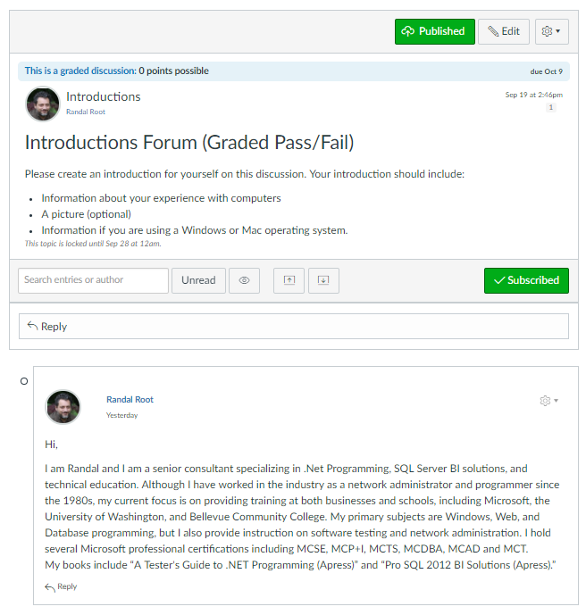

Figure 1: The Introduction Forum

**You're done!**